Requirements Elicitation

A mock interview was held between me and a classmate where I played the role of a software engineer and they played the role of a client whom I would develop a banking system for. From the interview held I was able to elicit the following requirements. The following organisational names are fictional used only for the purpose of education and generic development.

Developer- Motsholathebe Maatla Bowelo

Client on Behalf of BroadBankBotswana- Pako Daniel

NON-Functional Requirements

The non-functional requirements are categorised into 4 sections namely: Performance, Reliability, Usability, Scalability

1. Performance

* Recorded transactions should quickly be processed
* The system should be able to support multiple users with no lag

2. Reliability

* The system must be up and running at all times
* Transactions must be well detailed meaning they must either be complete or not registered entirely

3. Usability

* The banking system must have a simple user interface
* The system must have clear error messages and validation prompts
* The system must have descriptive documentation

4. Scalability

* Should allow users to have multiple accounts
* Able to support sudden increase of customers without performance drops

Functional Requirements

The functional requirements are categorised into 4 sections namely: Registration, Account Management, Transactions and Authentication & Security

1. Register Customers

* Be able to register customers with details names, address, employer details etc
* Be able to update the customer details
* View Customer Information

2. Account Management

* Allow customer to open multiple accounts namely savings, investment and cheque - View account details

3. Transactions

* Deposit funds into any account
* Withdraw funds from any account
* Automatically calculate and add interest to respective accounts
* View transaction history

4. Authentication & security

* Provide a safe login space for customers to use
* Ensure only customers can use the system
* Allow staff use system for management purposes

CLASS DIAGRAM

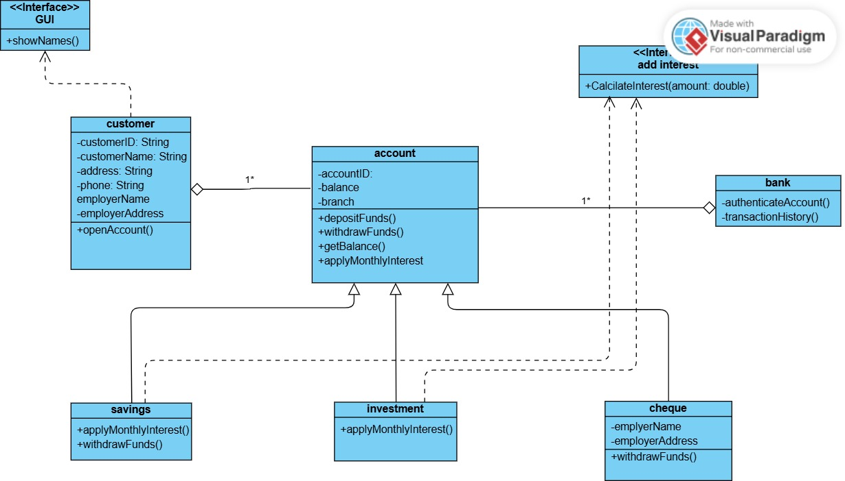

DEPOSIT SEQUENCE DIAGRAM

WITHDRAWAL SEQUENCE DIAGRAM

STATE DIAGRAM

USE CASE DIAGRAM

Mock Interview Record

Interviewer: What are the features or abilities you would like the system to have?

Client: We want a system that is secure for users, that will be able to register and accounts, and perform basic transactions such as deposit and withdrawal.

Interviewer:Are there restrictions on different accounts such as varying interest rates, etc?

Client: Yes savings accounts do not have withdrawals, investment accounts require an opening balance of P500.

Interviewer: Speaking of investment accounts ,what interest rates do they have?

Client: Savings accounts have 0.05% monthly while investment accounts earn 5% monthly.

Interviewer: Any security concerns?

Client: Yes the system must log in to the system safely with no vulnerability threats.

Interviewer: Who will use the system?

Client: Bank staff along with the customer to manage accounts and verify details.

Interviewer: Thank you for your time. Those are all the questions I have for you.

Client: Okay how long will development take?

Interviewer: I can’t give estimates at this time but we’ll keep in touch.

Client: Thank you.